Project 10-1: Using a Wireless Monitor Tool
Estimated Time: 30 minutes
Objective: Explore the features of a wireless monitor.
Description: Most Wi-Fi users are surprised to see just how far their wireless signal will reach, and if the network is unprotected, this makes it easy for an attacker hiding several hundred feet away to break into the network. There are several tools available that will show the different wireless signals from Wi-Fi networks that can be detected. In this project, you download and install the NirSoft WifiInfoView tool. You will need a computer with a wireless adapter, such as a laptop, to complete this project.
- Use your web browser to go to www.nirsoft.net/utils/wifi_information_view.html. (If you are no longer able to access the site through the web address, use a search engine to search for “NirSoft WifiInfoView.”)
- Scroll down and click Download WifiInfoView. Choose 32-bit or 64-bit depending on your operating system.
- Download the tool and when finished, extract the files and then launch the program.
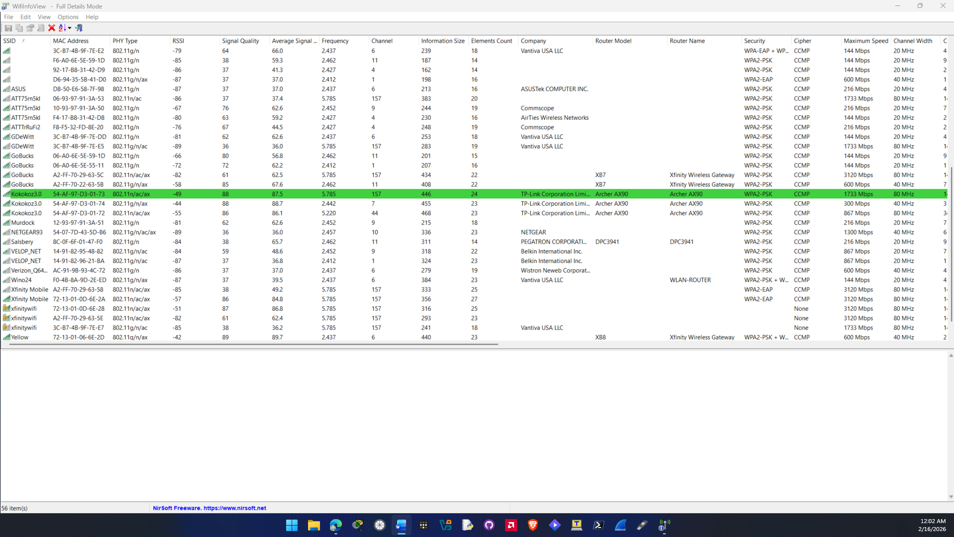

- Wait until WifiInfoView displays all Wi-Fi networks that it detects.
- Scan through all the information that is displayed. Does the amount of available information from Wi-Fi networks to which you are not connected surprise you?
No, it does not surprise me with the amount of available information on wifi networks. I have used a wifi tool like this before to analyze signal strength to different wireless networks.

- Scroll back to the first column of information.
- Under SSID, is there a service set identifier for each network? Why would an SSID not appear? Does disabling the broadcast of the SSID name give any enhanced level of security? Why not?
Not every network listed has an SSID. That’s because the SSID broadcast was disabled on the router. Yes it gives a basic level of security against threat actors that are not very skilled like script kitties by hiding the ability to see the network with basic tools but overall, it doesn’t protect you from threat actors that know what they are doing since they can use scanning tools to find your network.

- Note the value under the column MAC Address. How could a threat actor use this information?
A threat actor can use MAC spoofing to imitate the device and gain access to the network. They could also plant a man in the middle attack where they plant a router and all the packets go to that router instead since other devices on the network think that the device they planted is the real one.

- Under RSSI, the signal strength is displayed (lower numbers indicate a stronger signal).
- The Frequency column displays the frequency on which the network is transmitting, and the Channel column gives the corresponding channel. Click Channel to sort the channels. Is there any channel overlap? How could this be a problem?
Yes there is channel overlap between the networks. This could be a problem because the more networks broadcasting on that channel the slower networks can become due to interference on that channel.

- Double-click the Wi-Fi network to which you are currently connected. A window of the available information that is being transmitted through the Wi-Fi is displayed. This is the information that anyone can see regarding your Wi-Fi network. Close this window.
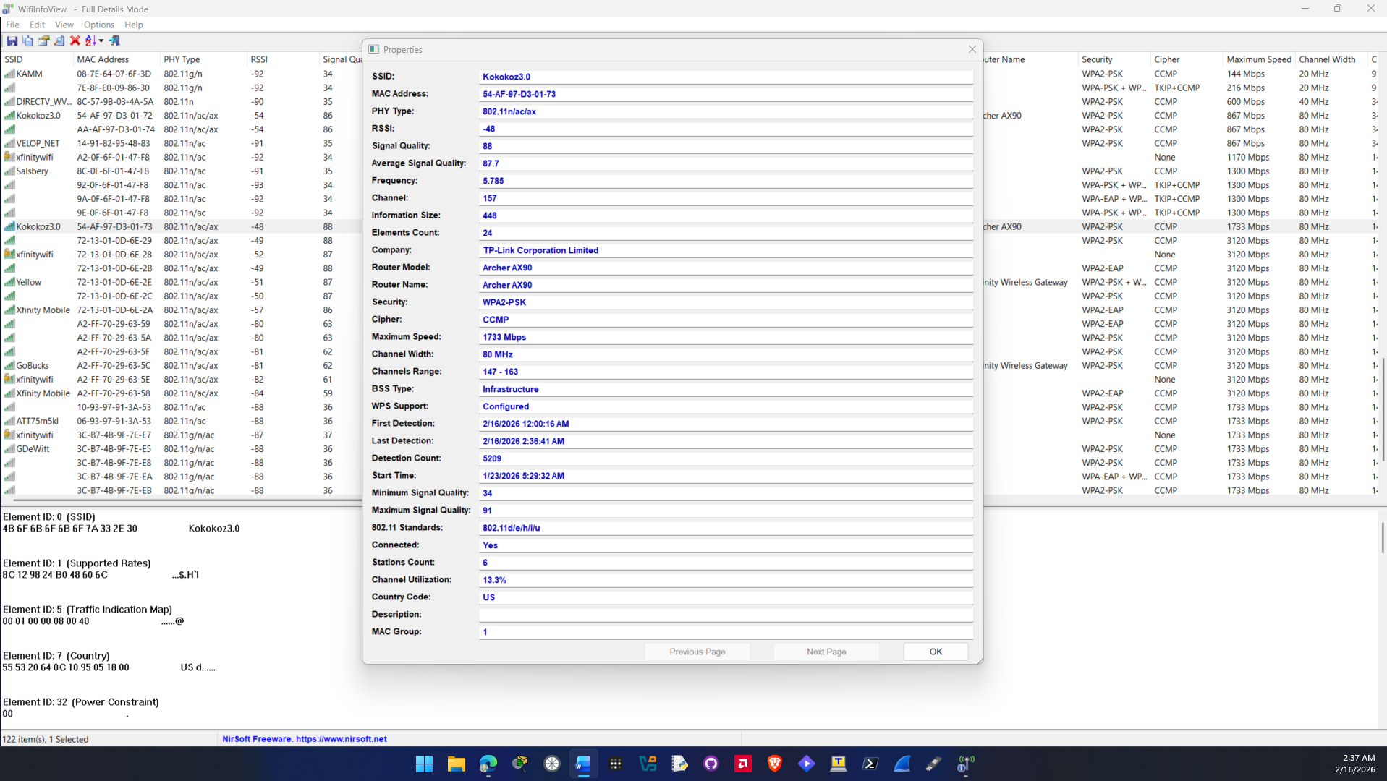

- Now select a network other than the one to which you are connected and double-click it to display information. After reading the information, close the window.
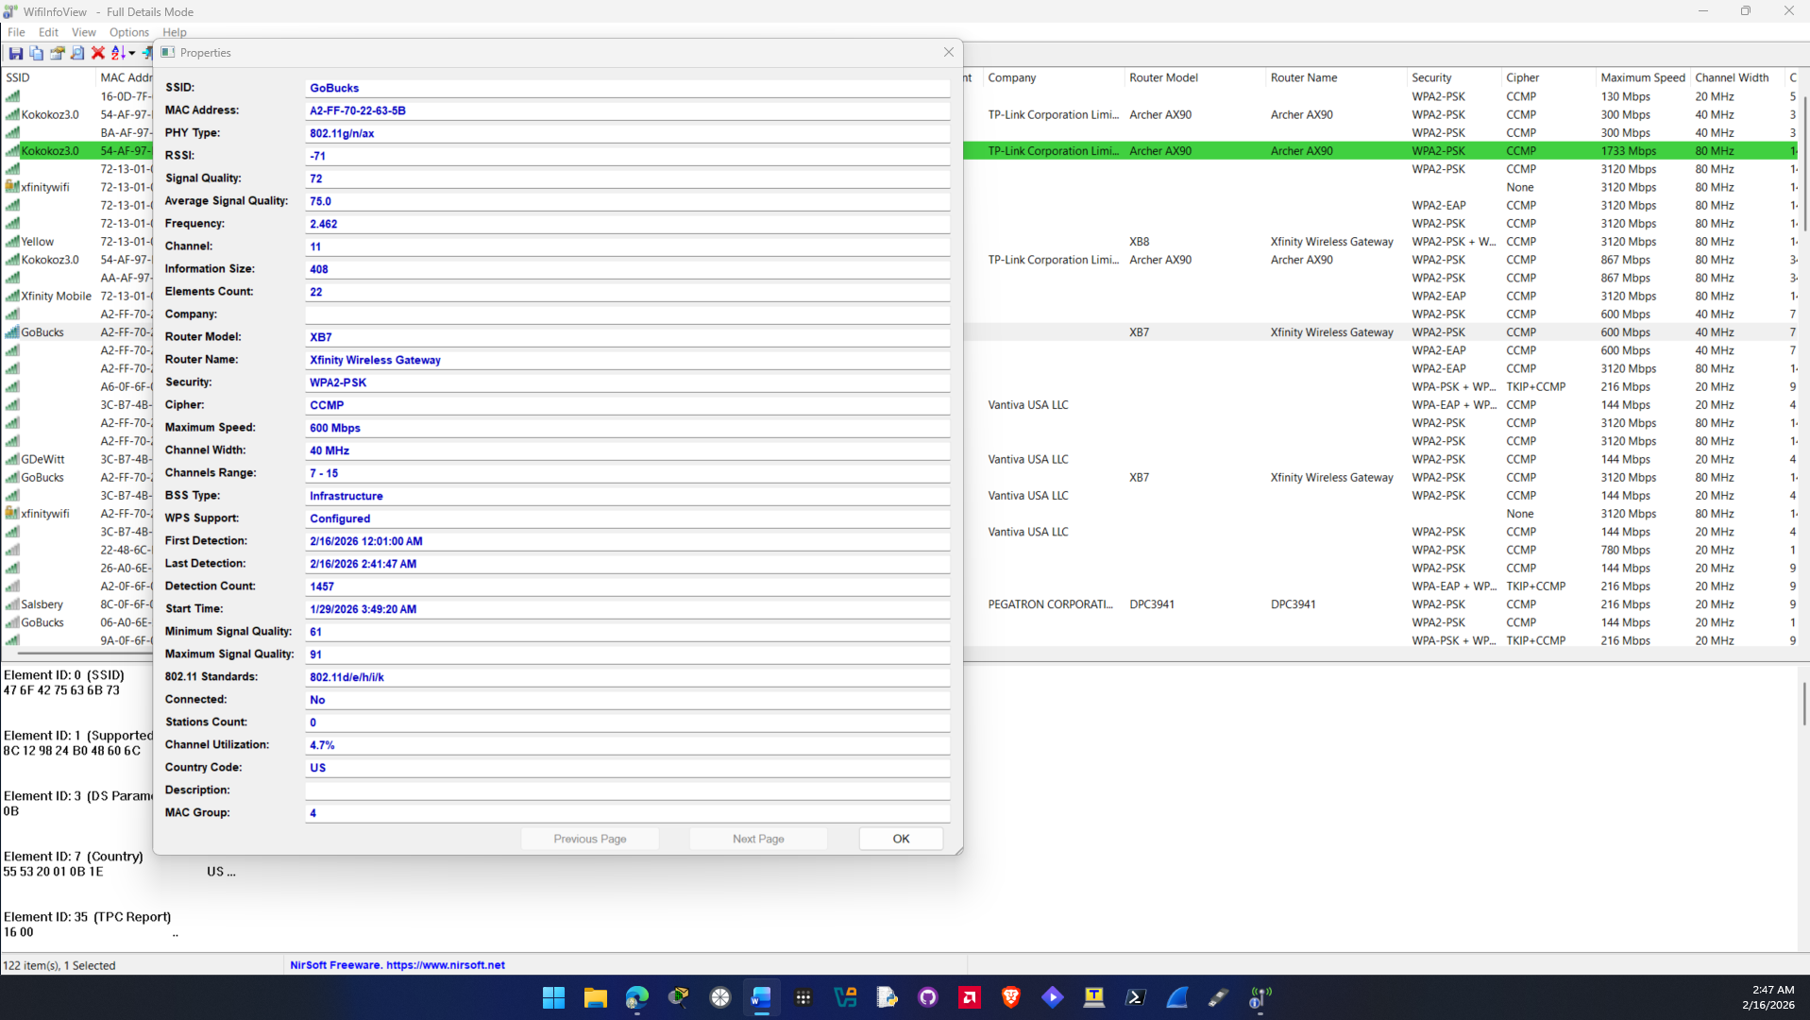

- Scroll to the Security and Cipher columns. What security are the networks using?
The security the networks are using are WPA2-PSK, WPA2-EAP, WPA3-Personal. CCMP for Cipher

- Scroll to WPS Support. How many networks have WPS turned on? Is this secure?
About half of the networks in the WifiInfoView have WPS turned on and Configured. Its insecure because attackers can just brute force and 8 digit pin number. Having a physical button also leaves a risk because if a threat actor gains physical access to the device then they can gain access to your network.

- What additional information do you find useful? What information would a threat actor find useful?
Other information I found useful was signal quality and the average of signal quality. I also found the maximum speed useful so you can see what protocol the router is running. Information that a threat actor would find useful would be the MAC addresses of the routers, router model and name could also be useful for threat actors to find out if there are any vulnerabilities that exist in the firmware of that routers model.

- Close all windows.

Criteria | Meets Requirements | Needs Improvement | Incomplete
Content | The assignment clearly and comprehensively addresses all questions in the assignment.  15 points | The assignment partially addresses some or all questions in the assignment.  8 points | The assignment does not address the questions in the assignment.  0 points
Organization and Clarity | The assignment presents ideas in a clear manner and with strong organizational structure. The assignment includes appropriate content, coverage of facts, arguments, and conclusions.  10 points | The assignment presents ideas in a mostly clear manner and with some organizational structure. The assignment includes appropriate content, coverage of facts, arguments, and conclusions.  7 points | The assignment does not present ideas in a clear manner or with a strong organizational structure. The assignment includes some appropriate content, but coverage of facts, arguments, and conclusions are not logically related and consistent.  0 points
Research | The assignment is based upon appropriate and adequate data collection and analysis of results from the activity or research from academically reliable sources.  5 points | The assignment is based upon adequate data collection and includes some analysis of results from the activity or research from academically reliable sources.  3 points | The assignment is not based upon appropriate data collection and includes no analysis of results from the activity or research from academically reliable sources.  0 points
Grammar and Spelling | The assignment has two or fewer grammatical and spelling errors.  5 points | The assignment has three to five grammatical and spelling errors.  3 points | The assignment has more than five grammatical and spelling errors, is incomplete, or is unintelligible.  0 points

